# Part 2: Improve the Battleship game

Modify the Battleship game from part 1to randomly place the ships and to allow the user to play against a computer opponent that randomly guesses positions.

If you haven’t already done part 1, you’ll need to do it first, unless it’s given to you as a starting point.

Prerequisites: Chapters 1 to 12.

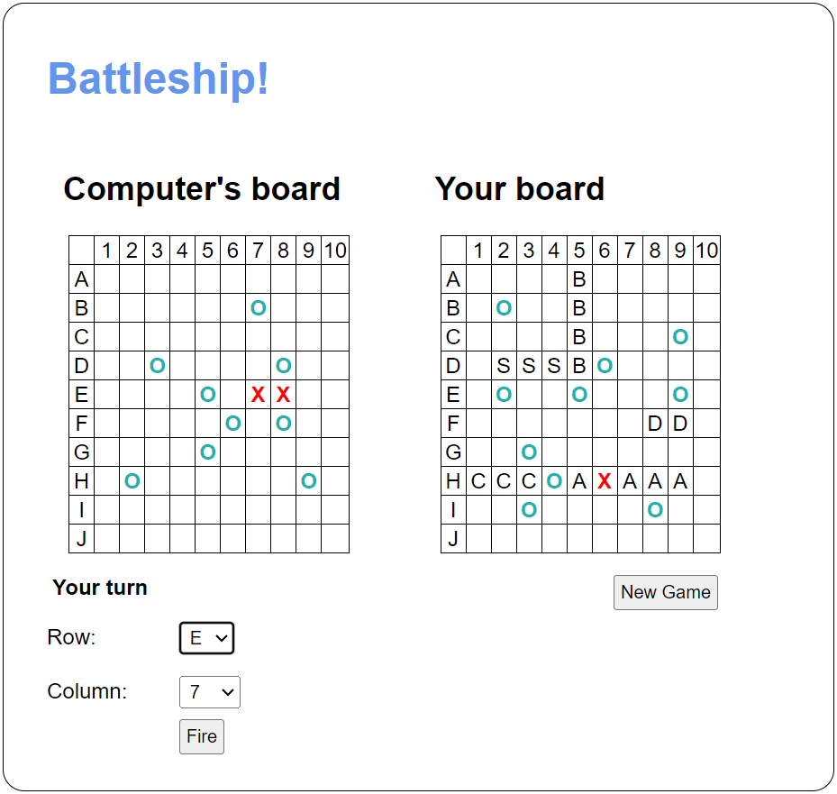

## Specifications

* The app has a game board for the user and for the computer. The user’s board displays the location of the user’s ships, while the computer’s ships are hidden.
* Each player has the five ships described in Part 1. The ships are placed in a random valid location on the player’s game board. To make it easier to tell the ships apart, use the first initial of the ship type rather than “X”.
* The app tracks the total possible hits for each player uses this value to determine a winner.
* When the Fire button is clicked, the app places an “X” or “O” on the Computer’s board at the location selected by the user. Then, the computer takes a turn and the app places an “X” or “O” on the User’s board at a location that’s selected randomly.
* After each turn, the app checks for a winner. If there’s a winner, the app notifies the user and displays the computer’s ships.
* When the New Game button is clicked, the game is reset.
* Use libraries and classes to organize your code and protect private state.